Test Number | Description | User Input | Expected Output | Actual Output
1 | SWC Bank Menu is displayed (L. Login  A. Add Account  E. Exit)  and user is prompted to enter a number | User started the program | Menu is displayed and user is prompted to enter a letter | Menu is displayed  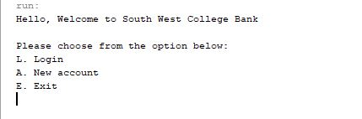
2 | User cannot enter an invalid letter or number then user a have the information entered to them again | User enters  invalid letter or number | Menu you pop up again prompting the user to try again | Menu you pop up again prompting the user to try again  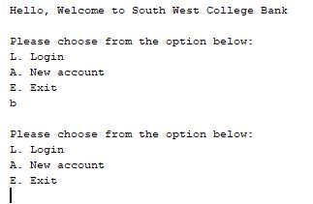
3 | When user selected option login in L the user is prompted to enter username | User enters a username | Asks user to enter correct username | 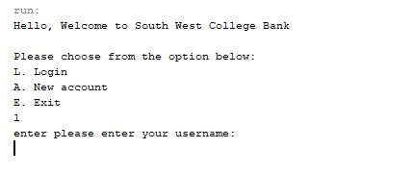  User enters correct username
4 | When the user enter a username is asked to enter a password | User enters a password | Ask the user to enter correct passwor | 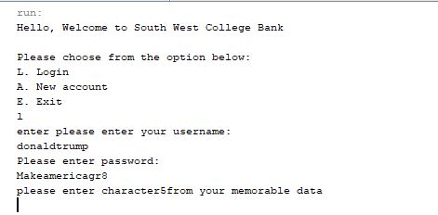  User enters correct password
5 | When user enters memorable data | User enter memroable data 1, 2 & 3 | Ask the user to add memorable data | 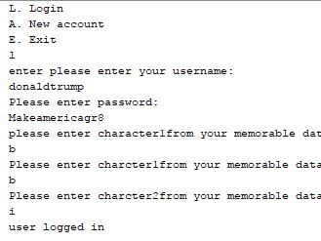  User enters memorable data user logs in
6 | When user enters invalid data | User add username, password and memorable data which are all incorrect | User is given a invlaid user id and starts from menu | 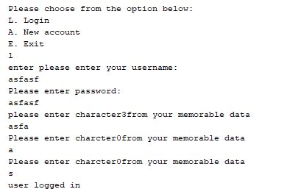  Invalid login failed most possible that the array list is not being recognise

7 | Selecting a new account | User input should be a | Selects new account setup | 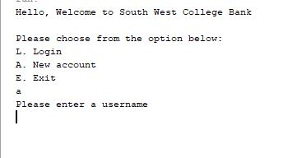  Selects new account setup
8 | Enter a new username  which should be between 6-12 character long | User inputs user name | User adds username  moves to passwords  then memorable data | 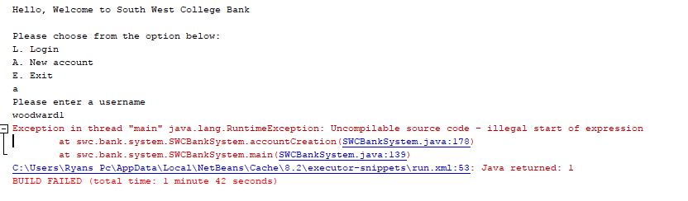  When entering anew username error messages appears due to unknown reasons listed on lines 178,135 &53 meaning test for adding new user has flailed

9 | When user selected exit under letter E | User enter E or e | E exits the programme | Exits and ends programme  